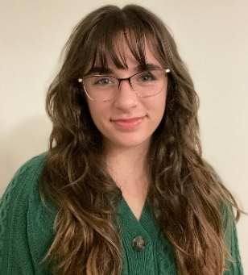
Annika Sophia Baker
Annikabaker.com Pronouns: She/Her/Hers Voice: Belt/Mix (F₃-B₆), Legit (F₃-C₆) Height: 5’2” Hair: Brown Eyes: Hazel
Musical Theatre
25th Putnam County Spelling Bee Rona-Lisa Dir. Mary Jo DuPrey Iowa State University Frozen Ensemble/Anna U/s Dir. Nicholas Amundson Des Moines Playhouse Head Over Heels Pamela Dir. Brad Dell Iowa State University Street Scene Olga Olsen Dir. Brad Dell Iowa State University Night of The Living Dead! Robin Graves Dir. Mary Jo DuPrey Iowa State University Baba (World Premier Musical) Fern Dir. Cason Murphy Iowa State University
Theatre
Our Community Carol Future Ghost Dir. Tiffany Antone Iowa State University
Romeo & Juliet Lady Capulet Dir. Katie Scarlett Iowa State University
She Kills Monsters Narrator/Gabbi Dir. Cason Murphy Iowa State University
Wunderkammer Albatross Dir. Tiffany Antone Iowa State University
Related Experience:
Santino Fontana in Concert Featured Soloist Maestro Joseph Giunta
Fairy Tales of The Anthropocene Stage Manager Dir. Amanda Petefish- Schrag
A Comedy of Errors Asst. Stage Manager Iowa Stage Theatre Company
ISU TV Spot Voice-Over ISU Admissions, ZLR Ignition
Program Me, I Am A Machine Background Vocalist Liam Ray III, The Dream Eaters
Awards
- Senior Finalist, Bill Riley Talent Search (2023)
- NATS 2nd Place MT Regional (2024, 2022), State (2022), 1st Place Commercial Music State (2025)
- Irene Ryan Nominee (2 years), Musical Theatre Finalist KCACTF 2022
Education & Training
Voice: Chad Sonka Vocal Studio (Opera and Classical training, Musical Theatre Focus), Mary Jo DuPrey (Vocal Masterclass and Lessons)
Acting: Iowa State University, Period Styles (Amanda Petefish-Schrag), Directing (Brad Dell), Musical Theatre (Cason Murphy)
BA in Performing Arts from Iowa State University: Emphasis in Musical Theatre, Technical Design
Special Skills
Dance: 11 years, (7 years Competitive) in Tap, Ballet, and Jazz at Dance-A-Cross Studio, West Des Moines
Stage Combat: Master Class Education (Brandon Brockshus)-Unarmed Combat and Simple Weapons, Introductory Sword Fighting, Introductory Quarterstaff Fighting
Additional Skills: Valid Iowa Driver’s License-including Class-B CDL certification, Stage Management, House Management, Child Management, expertise in paperwork, Excel, a fondness for PowerPoints, middle harmonies, and running or playing Table-Top Role Playing Games (proficiency in D&D, Monster of The Week)

